Pupil premium strategy statement

This statement details our school’s use of pupil premium and recovery premium for the 2023 to 2024 academic year, to help improve the attainment of our disadvantaged pupils.

It outlines our pupil premium strategy over the three year period ending in July 2024 and how we intend to spend the funding in this academic year and the effect that last year’s spending of pupil premium had within our school.

School overview
Detail | Data
School name | Banwell Primary School
Number of pupils in school | 124 (21/11/2023)
Proportion (%) of pupil premium eligible pupils | 18/124 = 14.5%
Academic year/years that our current pupil premium strategy plan covers (3 year plans are recommended) | 2021-2024
Date this statement was published | 20th December 2023
Date on which it will be reviewed | 15th July 2024
Statement authorised by | Claire Pocock  Headteacher
Pupil premium lead | Paul Davis  Deputy Headteacher
Governor / Trustee lead | Mrs Tara Wright
Funding overview
Detail | Amount
Pupil premium funding allocation this academic year | £41,055
Recovery premium funding allocation this academic year | £3,335
Pupil premium funding carried forward from previous years (enter £0 if not applicable) | £0
Total budget for this academic year  If your school is an academy in a trust that pools this funding, state the amount available to your school this academic year | £44,390

Part A: Pupil premium strategy plan

Statement of intent
- We will model the high aspirations and expectations we have for all of our children.
- We will build strong relationships with all children and their parents so that we fully understand their aspirations and any challenges they may face.
- We will provide a broad curriculum with carefully chosen content that is well-structured and logically sequenced. Our curriculum is ambitious and designed to give all learners, the knowledge, skills and cultural capital they need to take advantage of future opportunities, responsibilities and experiences of further learning and employment - to succeed in life.
‘A curriculum exists to change the pupil, to give the pupil new power. One acid test for a curriculum is whether it enables even lower-attaining or disadvantaged pupils to clamber in to the discourse and practices of educated people, so that they gain the powers of the powerful.’ Christine Counsell, 2018
- We will enrich children’s education with opportunities for them to have fun, learn and celebrate with other children from across the trust.
- We will prioritise ensuring that every child accesses the very best teaching. We will challenge and support staff to keep improving through high quality programmes of professional development.
‘Teaching quality is a crucial factor in raising pupil attainment.’
Department for Education, 2020
- We will teach all children to be academically competent learners. The pedagogical approaches we use will enable and expect all children to actively engage in learning.
- We will create purposeful classroom environments that allow our pupils to focus on learning.
- We will ensure that we use assessment information effectively so that we give the right feedback to every child and adapt our teaching in such a way that we are confident that every child is learning.
- When pupils require additional support we will plan and deliver the most appropriate additional and different provision based on the evidence of what has greatest impact.
- We will adapt our curriculum so that it remains ambitious but also meets the needs of pupils with SEND, developing their knowledge, skills and abilities to apply what they know and can do with increasing fluency and independence.
- We will play our part in addressing non-academic barriers, including those that affect children’s mental, social, emotional and physical well-being.
- We will use pupil premium to help ‘disadvantaged’ pupils by improving their progress and the outcomes they achieve and we will use catch-up premium to support pupils to catch up for lost teaching time. We will have a clear justification for how we choose to spend the premiums and we will monitor and evaluate the impact of the spends robustly.
‘Good teaching is the most important lever schools have to improve outcomes for disadvantaged pupils. Using the Pupil Premium to improve teaching quality benefits all students and has a particularly positive effect on children eligible for the Pupil Premium.’ EEF June 2019
- Strategies we use will be carefully selected based on secure evidence that indicates they will impact positively to resolve identified problems. Where we do not have evidence of a strategy having impact we will stop using it.

Challenges
Banwell Primary School is located within a rural, village community, approximately 2.5 miles from the outskirts of Weston-Super-Mare, a large coastal town. The wider area has a very varied context, with affluent pockets in both the rural fringe and within some of Weston-Super-Mare’s scenic suburbs, as well as the significant levels of deprivation familiar to many coastal towns and their environs. The Index of Multiple Deprivation ranks Banwell as being within the 40% most deprived neighbourhoods in the country. Significantly however, the Income Deprivation Affecting Children Index ranks Banwell as amongst the 20% of most deprived neighbourhoods in the country.
Challenge number | Detail of challenge
1 | Assessments, observations, and discussions with pupils indicate underdeveloped oral language skills and vocabulary gaps among many disadvantaged pupils. These are evident from Reception through to KS2 and in general, are more prevalent among our disadvantaged pupils than their peers.
2 | Assessments, observations, and discussions with pupils suggest disadvantaged pupils generally have greater difficulties with phonics and spelling than their peers. This negatively impacts their development as readers.
3 | Internal assessments indicate that Maths attainment among disadvantaged pupils is significantly below that of non-disadvantaged pupils.  # The number of disadvantaged pupils in the YR and Y1 cohorts is statistically insignificant for the purpose of comparing the baseline assessment data of disadvantaged and non-disadvantaged pupils.
4 | Our observations and discussions with pupils and families indicate that the well-being of some children was impacted by restricted access to school as a consequence of Covid-19. This has had a very varied impact: we were able to offer places to 18 vulnerable children during periods when classrooms were closed to many pupils, ensuring support for many of our children in receipt of pupil premium funding.  For many of our younger children in particular, there was reduced interaction with peers at a critical time for the development of language and socialisation skills. The consequence in school is that peer to peer relationship issues are less easily resolved without adult intervention than previously.
5 | Our attendance data from 01/09/2023 – 20/11/2023 indicates that attendance among disadvantaged pupils remains lower than for non-disadvantaged pupils. Attendance for all children is 94.7% (roughly the national average attendance), whilst for children in receipt of Pupil Premium funding, attendance is 90.84%. A very small group of pupils account for much of this gap.  Our assessments and observations indicate that absenteeism is negatively impacting disadvantaged pupils’ progress.

Intended outcomes
This explains the outcomes we are aiming for by the end of our current strategy plan in Summer 2023/24, and how we will measure whether they have been achieved.
Intended outcome | Success criteria
Improved phonics and spelling skills among disadvantaged pupils. | Assessments and observations indicate continuing improvement in phonics and spelling assessment results amongst disadvantaged pupils. This is then applied in extended writing tasks, with children able to independently access supporting resources.
Improved reading attainment among disadvantaged pupils. | Internal data from KS2 SATs data and the Summer NfER reading tests, shows that in 2023/24, more than 70% of disadvantaged pupils across KS2 met the expected standard.  # The leadership team have deliberately chosen not to focus exclusively on end of KS2 results as the data set will be statistically insignificant.
Improved maths attainment among disadvantaged pupils. | Internal data from KS2 SATs data and the Summer NfER maths tests, shows that in 2023/24, more than 70% of disadvantaged pupils across KS2 met the expected standard.  # The leadership team have deliberately chosen not to focus exclusively on end of KS2 results as the data set will be statistically insignificant.
To achieve and sustain improved wellbeing for all pupils in our school, particularly our disadvantaged pupils. | Sustained high levels of wellbeing from 2023/24 demonstrated by:  - qualitative data from student voice, student and parent surveys and teacher observations  - an increase in the ability of children to manage conflict in relationships without the intervention of adults  - a significant increase in participation in enrichment activities, particularly among disadvantaged pupils
To achieve and sustain improved attendance for all pupils, particularly our disadvantaged pupils. | Sustained high attendance from 2023/24 demonstrated by:  - the overall attendance rate for all pupils being at least 96.1%, and the attendance gap between disadvantaged pupils and their non-disadvantaged peers being reduced by 1.5%.  - the percentage of all pupils who are persistently absent being below 8% and the figure among disadvantaged pupils being no more than 2% lower than their peers.

Activity in this academic year
This details how we intend to spend our pupil premium (and recovery premium funding) this academic year to address the challenges listed above.
Budgeted cost: £1,190 (2022/23 was £7,658)
Activity | Evidence that supports this approach | Challenge number(s) addressed
Purchase of standardised diagnostic assessments.  Training for staff to ensure assessments are interpreted and administered correctly. | Standardised tests can provide reliable insights into the specific strengths and weaknesses of each pupil to help ensure they receive the correct additional support through interventions or teacher instruction:  Standardised tests | EEF | 1, 2, 3, 4
In September 2022, we reviewed our synthetic phonics programme and moved to the Extend Letters and Sounds programme to secure stronger phonics teaching for all pupils.  Throughout 2022/23, we are ensuring that staff across the school are trained in the programme and able to deliver phonics, early spelling and relevant KS2 interventions in phonics. | Phonics approaches have a strong evidence base that indicates a positive impact on the accuracy of word reading (though not necessarily comprehension), particularly for disadvantaged pupils:  Phonics | EEF | 2
Enhancement of our maths teaching and curriculum planning in line with DfE and EEF guidance.  Our priority for 2023/24 is to continue to improve the effective teaching of problem solving in Maths and to introduce a programme for the more effective teaching of times tables in Key Stage 2. | The DfE non-statutory guidance has been produced in conjunction with the National Centre for Excellence in the Teaching of Mathematics, drawing on evidence-based approaches:  Maths_guidance_KS_1_and_2.pdf (publishing.service.gov.uk)  The EEF guidance is based on a range of the best available evidence:  Improving Mathematics in Key Stages 2 and 3 | 3
Improve the quality of social and emotional (SEL) learning.  SEL approaches will be embedded into routine educational practices and supported by professional development and training for staff. | There is extensive evidence associating childhood social and emotional skills with improved outcomes at school and in later life (e.g., improved academic performance, attitudes, behaviour and relationships with peers):  Social and Emotional Learning | EEF | 4, 5
Targeted academic support (for example, tutoring, one-to-one support structured interventions)
Budgeted cost: £30,000
Activity | Evidence that supports this approach |  | Challenge number(s) addressed
Additional phonics sessions targeted at disadvantaged pupils who require further phonics support. | Phonics approaches have a strong evidence base indicating a positive impact on pupils, particularly from disadvantaged backgrounds. Targeted phonics interventions have been shown to be more effective when delivered as regular sessions over a period up to 12 weeks:  Phonics | EEF |  | 2
HLTA provides familiar and consistent class cover
Teaching Assistant intervention within classroom to support disadvantaged pupils to access the core class learning via pre-teaching and targeted support, with a focus on Writing. | In class interventions have the advantage of enabling all children to access the core curriculum. Moderate impact for moderate cost.  Teaching Assistant Interventions | EEF |  | 1,2,3,4,5
Engaging with the National Tutoring Pro-gramme to provide a blend of tuition, mentoring and school-led tutoring for pupils whose education has been most impacted by the pandemic. A significant proportion of the pupils who receive tutoring will be disadvantaged, including those who are high attainers.  We have been unable to continue with this strand from September 2023 as a consequence of changes to the funding structure. | Tuition targeted at specific needs and knowledge gaps can be an effective method to support low attaining pupils or those falling behind, both one-to-one:  One to one tuition | EEF  And in small groups:  Small group tuition | Toolkit Strand | EEF |  | 4
Wider strategies (for example, related to attendance, behaviour, wellbeing)
Budgeted cost: £13,200
Activity | Evidence that supports this approach | Challenge number(s) addressed
Whole staff training on behaviour management and well-being approaches with the aim of developing our school ethos and improving behaviour across school. | Both targeted interventions and universal approaches can have positive overall effects:  Behaviour interventions | EEF | 5
Contribution to Learning Mentor salary to support pupils and staff in managing behaviour and engaging with families to embed desired changes. | Engaging with parents has moderate impact for low cost:  Parental engagement | EEF | 4,5
Embedding principles of good practice set out in the DfE’s Improving School Attendance advice.  This will involve training and release time for staff to develop and implement new procedures and appointing attendance/support officers to improve attendance.  Support for breakfast club to allow working parents of disadvantaged pupils to access the employment ladder.  Contribution to Learning Mentor salary to lead attendance strand. | The DfE guidance has been informed by engagement with schools that have significantly reduced levels of absence and persistent absence. | 6
Providing access to wider experiences |  | 4
Contingency fund for acute issues. | Based on our experiences and those of similar schools to ours, we have identified a need to set a small amount of funding aside to respond quickly to needs that have not yet been identified. | All
Total budgeted cost: £44,390

Part B: Review of outcomes in the previous academic year

Pupil premium strategy outcomes
This details the impact that our pupil premium activity had on pupils in the 2022/2023 academic year.
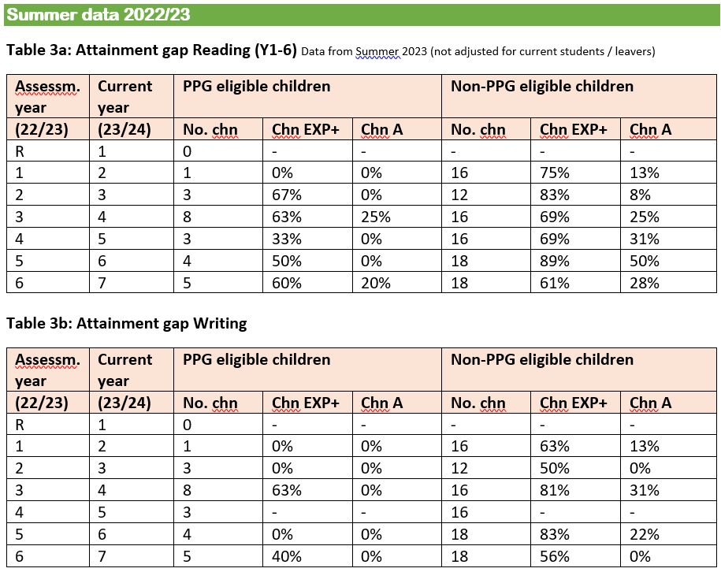
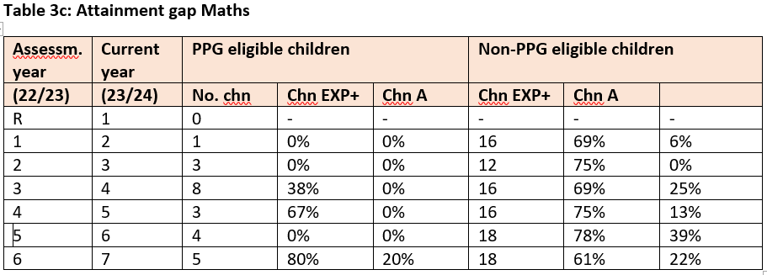

Further information
Additional activity
Our pupil premium strategy is supplemented by additional activity that is not being funded by pupil premium or recovery premium. That will include:
- embedding more effective practice around feedback. This is an ELAN MAT priority, focusing on the key elements that we describe as do, think, tweak. EEF evidence on feedback demonstrates this has significant benefits for pupils, particularly disadvantaged pupils.
- utilising a DfE grant to train a senior mental health lead. The training we have selected will focus on the training needs identified through the online tool: to develop our understanding of our pupils’ needs, give pupils a voice in how we address wellbeing, and support more effective collaboration with parents.
The school and our incredibly active local community have also supported our more vulnerable families in the following ways:
Foodbank
In March 2020, the school and Banwell Parish Council set up a foodbank in the first lockdown which initially operated from the school and subsequently from the nearby Children’s Centre. The foodbank remains in place (December 2022) and the school is a registered foodbank outlet.
Since September 2022, we have been a partnership organisation for our local Co-op. In December 2022, they donated fifty £10 food vouchers to food bank users and to all children at the school in receipt of Pupil Premium funding.
Other support for families in the holidays
Word Wizard. In 2021, and previously, a member of the local community who proof reads books, donated enough books for every child in receipt of Pupil Premium funding to have a book as a present for Christmas.
Christmas 2022, the Parish Council supplied a gift hamper for our most vulnerable families for Christmas, and the Salvation Army supplied toys for the same families, regardless of whether the families live within the Parish Council boundary or not.
An anonymous local resident also funded ‘Chocs for Champs,’ providing a gift box of chocolates for all pupil premium eligible children and all young carers at the school in 2019. We have acted as the regional hub for the project since 2021 and at Easter 2022 accessed funding for presents to over 600 children across the wider region of North Somerset and the neighbouring County of Somerset.
At Christmas 2023, the Parish Council distributed seven food hampers to families with PPG-eligible children, along with a donation of toys. In addition, HAF are providing ice skating family tickets at the Tropicana to all families who qualify, in receipt of benefits related free school meals, Children in Care and children with SEND.

http://dclgapps.communities.gov.uk/imd/iod_index.html#

