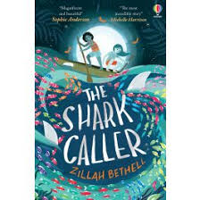  Term 1 – 8 weeks  James Reeves Poetry  Writing poetry - (2 weeks)  The Shark Caller  Narrative – setting description (2 weeks)  Non-chronological report – Sharks (3 weeks)  Malala’s Magic Pencil  Biography - (1 week)  Poetry comparisons – (1 week)  Rainbow I hate poems | 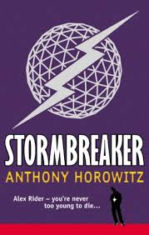  Term 3 – 6 weeks  Stormbreaker  Discussion text – Should Alex become a spy? (2 weeks)  Beowulf Epic Poetry  Persuasive letter writing (2 weeks)  The Piano from Literacy Shed  Narrative/ flashback – (2 weeks) | 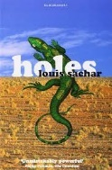  Term 5 – 5 weeks  Holes  Narrative – beginning of Stanley’s story (2 weeks)  Newspaper report – Stanley’s arrest (2 weeks)  Holes playscript - (1 week)  Poetry – Whose Land? Benjamin Zephaniah  Myself Edgar Guest
Term 2 – 7 weeks  Malala’s Magic Pencil  Biography - (2 weeks)  Stormbreaker  Setting description/ narrative – (3 weeks)  Talking Turkeys (1 week) | 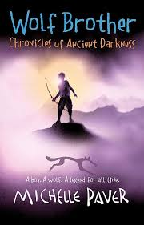  Term 4 – 6 weeks  Wolfbrother  Information text Wolves – (2 weeks)  Quest narrative – (4 weeks)  VIPERS poetry in reading (2 weeks) | 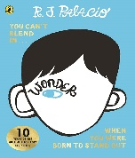  Term 6 – 7 weeks  Holes playscript - (1 week)  Wonder  Diary entries - (3 weeks)  Instructions– (2 weeks)  Poetry (1 week) – compare two poems
Writing Overview and Cannon of Books Year 6 Banwell 2024/2025

