Design Technology: Task sheets for individual student folders
- Outline of the task, including steps, deadlines and success criteria
- Initial and redrafted designs
- Learning about a designer
- The construction process – photographs + stem sentences with ‘what went right’, ‘ebi’
- Evaluation including test of whether or not it met its purpose and teacher evaluation against Success Criteria feeding into exceptions sheets
https://static1.squarespace.com/static/56d8b7334d088e67305565d3/t/5ef5a2106f24095395b55d03/1593156112981/Year+1+DT+Week+5.pdf
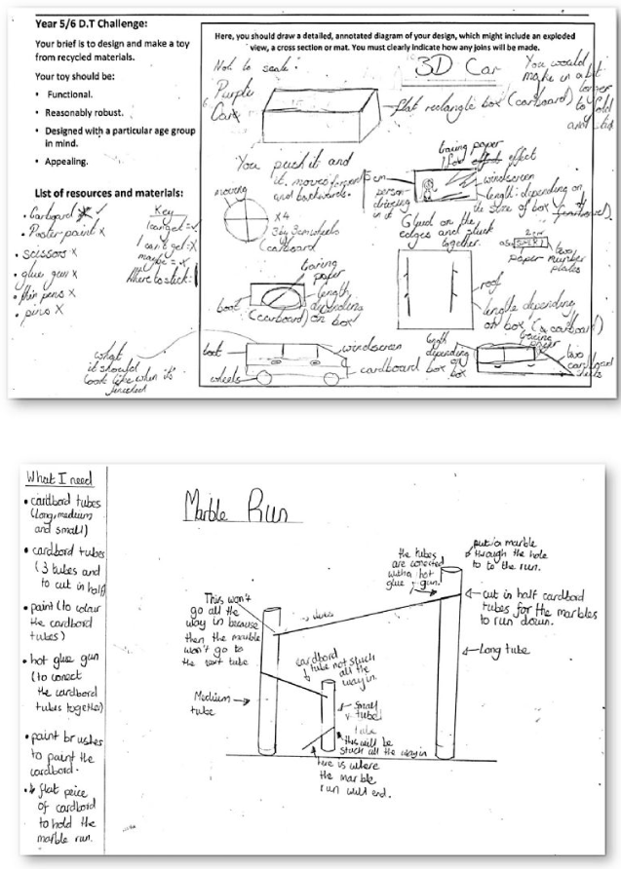
Design Technology : The task Step 1
Year |  | Term and date
Your task | Teacher to type the outline here before printing the sheet. No more than two sentences.
Steps | Teacher to type  1.  2  .
Deadlines
Success Criteria
WAGOLL | As an image/s, possibly with a link to a specific artist
Design Technology: My initial designs Step 2
The task | Teacher to type the outline here before printing the sheet. No more than two sentences.
What I want to improve about my designs

What I like about my designs

What resources I need to complete my design.

Success Criteria | Reprint so that children can tick off

Design Technology: Learn about a designer Step 3
Written information, with plenty of images

What I think
Children to add a written response

Design Technology: The construction process Step 4
The task | Teacher to type the outline here before printing the sheet. No more than two sentences.
What went well

What I want to change.

How did I improve my final piece and my understanding?

Design Technology: Evaluation Step 5
The task | To sew a Christmas bauble.
What went well?

What I would do differently next time.

Teacher evaluation

